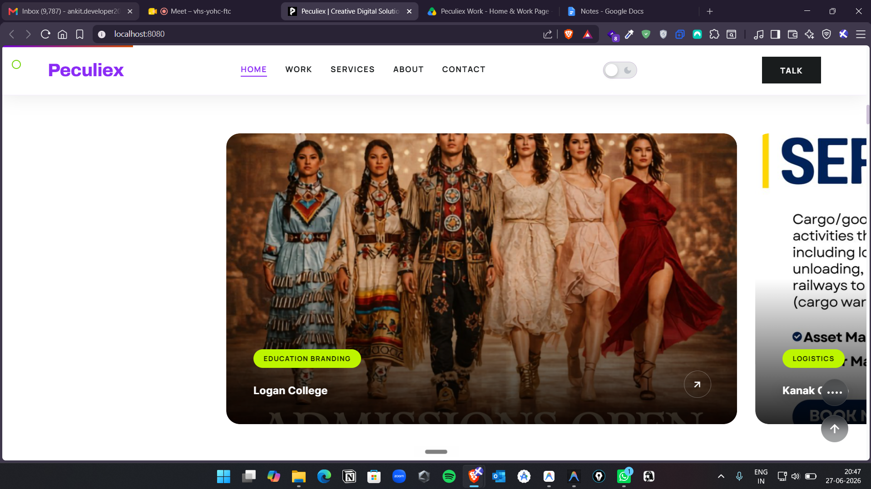

Cover image change 16:9 in laptop 6 cards only

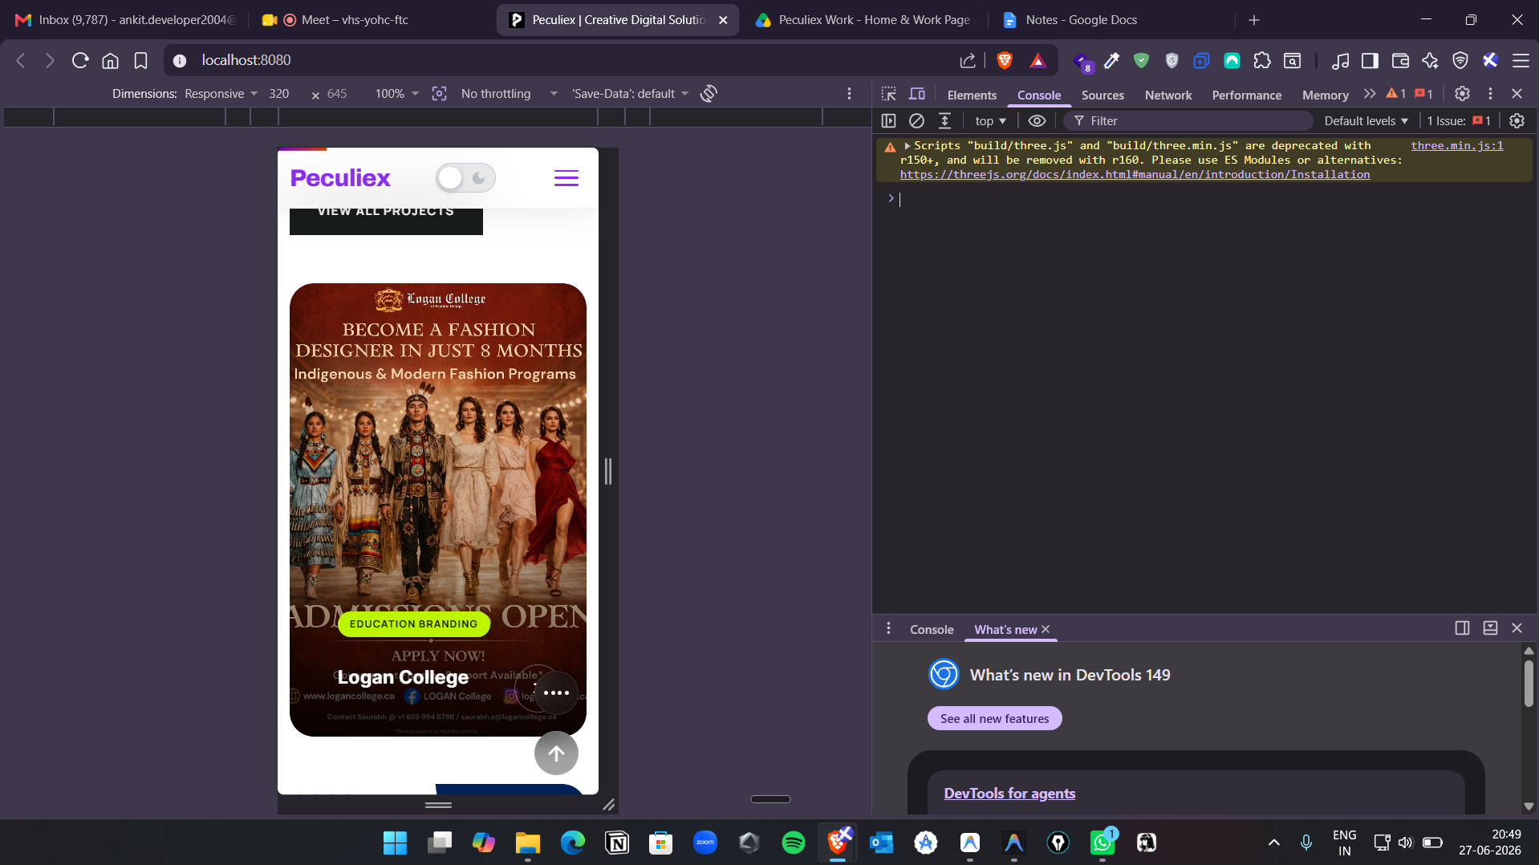

Show 6 cards. With same square size.
Floating effect While scrolling in the mobile

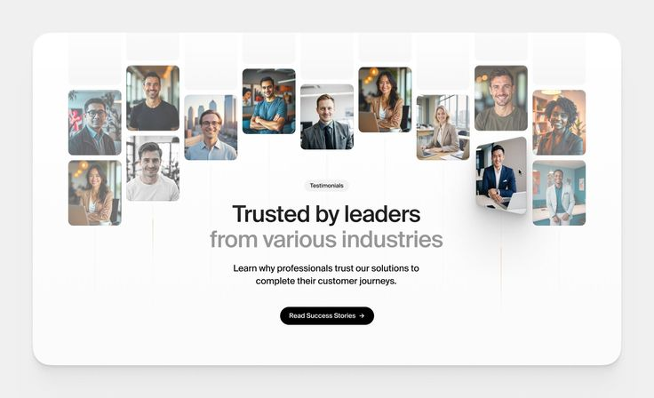

Trusted by businesses from various industries- main heading

Read success stories- button and link with work page.

Replace this section on the home page.
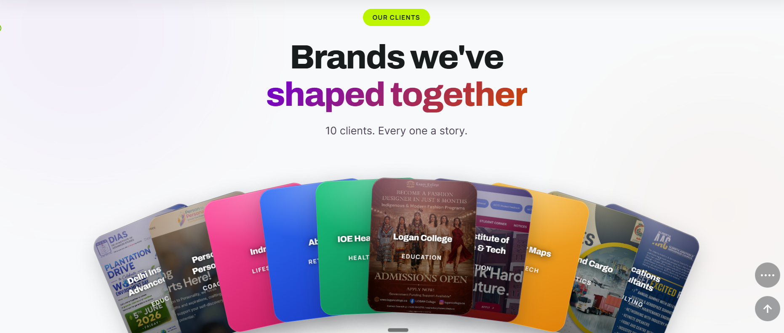

localhost:8080/work.html

Content of work page

Portfolio Pop-up Content

Delhi Institute of Advanced Studies (DIAS), Rohini
Services Delivered
· 360° Digital Marketing Management
· Website Maintenance & Optimization
· SEO
· Social Media Management (Instagram & Facebook)
· Graphic Designing
· Video Editing & AI-Based Content Creation
· Brochure, Flyer & Admission Collateral Design
· Event Branding (Flags, Standees, Notice Boards & Promotional Assets)
Key Impact
· Managed the institute's complete digital marketing ecosystem under one agency.
· Maintained a consistent brand identity across 20+ online and offline marketing touchpoints.
· Improved website performance through continuous maintenance and optimization.
· Strengthened online visibility with ongoing SEO implementation.
· Delivered high-quality creative assets supporting admissions, events, and institutional branding.

Delhi Institute of Science & Technology (DIST)
Services Delivered
· Website Management
· Website Updates & Maintenance
· Social Media Management
· Facebook & Instagram Lead Generation Campaigns
· Graphic Designing for Admission Campaigns
Key Impact
· Generated qualified student enquiries through Meta lead generation campaigns.
· Improved online visibility during admission seasons.
· Maintained an updated and professionally managed institutional website.
· Delivered consistent branding across digital platforms.
· Supported student admissions with performance-focused marketing campaigns.

Abiir
Services Delivered
· Shopify E-commerce Website Development
· Website Maintenance
· Razorpay Integration
· Product Listing & Catalogue Management
· Social Media Management
· Graphic Designing
· AI-Based Promotional Videos
Key Impact
· Built a complete e-commerce ecosystem for online sales.
· Enabled secure online payments.
· Improved product presentation through structured catalogue management.
· Established a premium digital brand identity.
· Delivered continuous website support.

Indraini
Services Delivered
· Website UI/UX Design
· Responsive Website Development
· Product Showcase Design
· Mobile Optimization
Key Impact
· Created a modern online shopping experience.
· Enhanced user experience with responsive design.
· Strengthened the brand's digital presence.
· Optimized across desktop and mobile devices.

Logan College
Services Delivered
· Social Media Management
· AI-Based Video Creation
· Graphic Designing
· Social Media Creatives
· Banners, Flags & Branding Collateral
Key Impact
· Maintained a professional social media presence.
· Produced AI-powered promotional videos.
· Delivered consistent branding.
· Supported admission campaigns with impactful creatives.

PersonToPersonality (Canada)
Services Delivered
· Website Development
· Course Integration
· Website Content Management
· Website Updates
· Responsive Website Optimization
Key Impact
· Built a professional learning platform.
· Improved course accessibility.
· Organized educational content.
· Developed a scalable website.

Institute of Eminence Healthcare (IOE Healthcare)
Services Delivered
· Facebook Lead Generation Campaigns
· Instagram Advertisement Campaigns
· Meta Ads Management
· Student Acquisition Strategy
Key Impact
· Generated qualified admission enquiries.
· Reached prospective paramedical students.
· Optimized campaigns for lead quality.
· Supported institutional growth.

Kanak Cargo & Travels
Services Delivered
· Graphic Designing
· Social Media Creatives
· Promotional Graphics
· WhatsApp Marketing Designs
Key Impact
· Delivered professionally branded creatives.
· Improved visual consistency.
· Created reusable marketing assets.
· Enhanced brand communication.

Gratification Consultants
Services Delivered
· Social Media Graphic Designing
· Carousel Design
· Canva Reel Creation
· Marketing Collateral Design
· Client Branding Support
Key Impact
· Delivered engaging content for Alberta Aviation (Gratification’s client).
· Improved storytelling through reels and carousels.
· Maintained consistent branding.
· Supported client marketing with quality creatives.

Sagar Maps
Services Delivered
· Website Design & Development
· Website Content Management
· Website Updates
· Website Maintenance
· Responsive Website Optimization
Key Impact
· Built a professional online presence.
· Developed a responsive website.
· Improved client accessibility.
· Ensured reliable website performance.

Services page

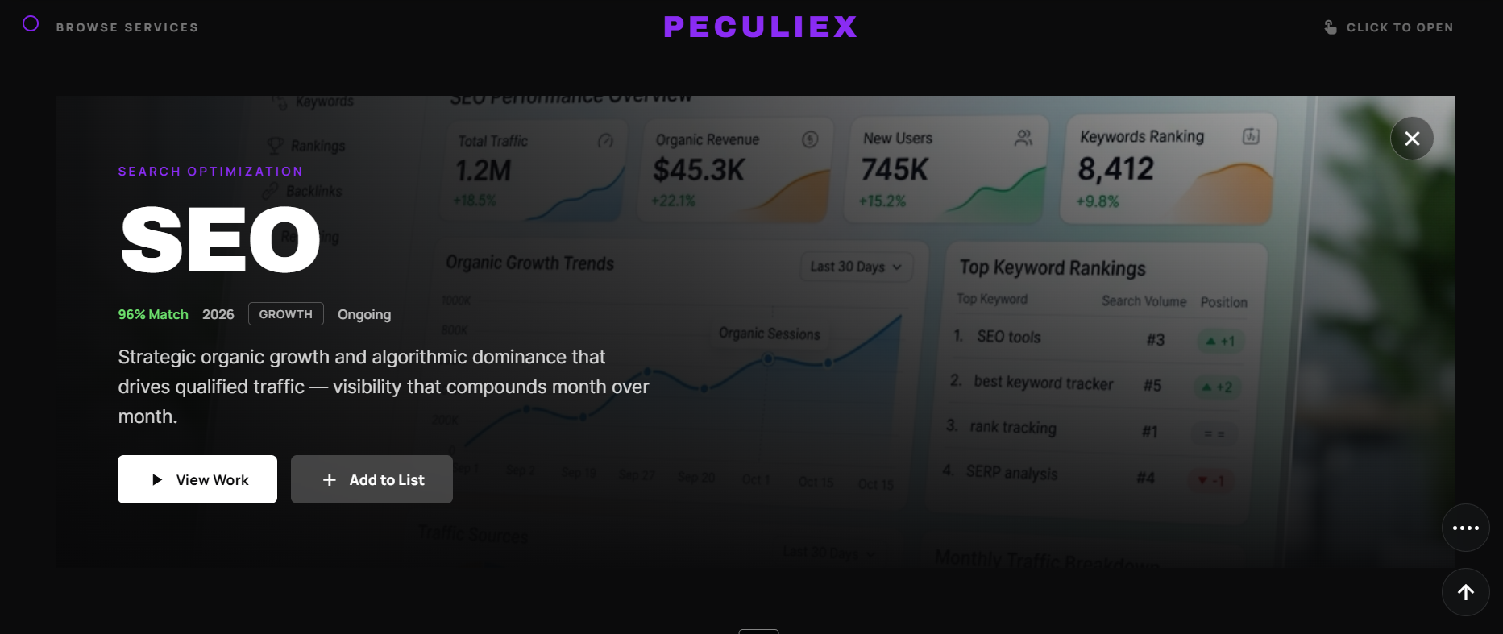

Replace add to list with connect now.

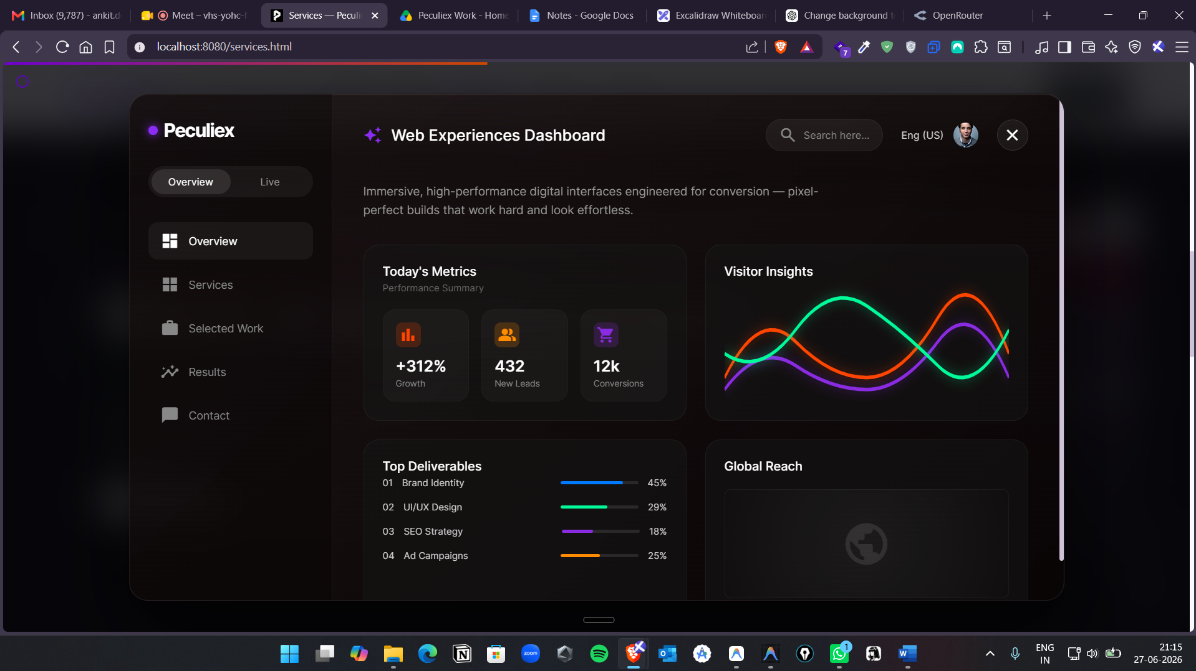
Change the content on the view work, also the dashboard screen.

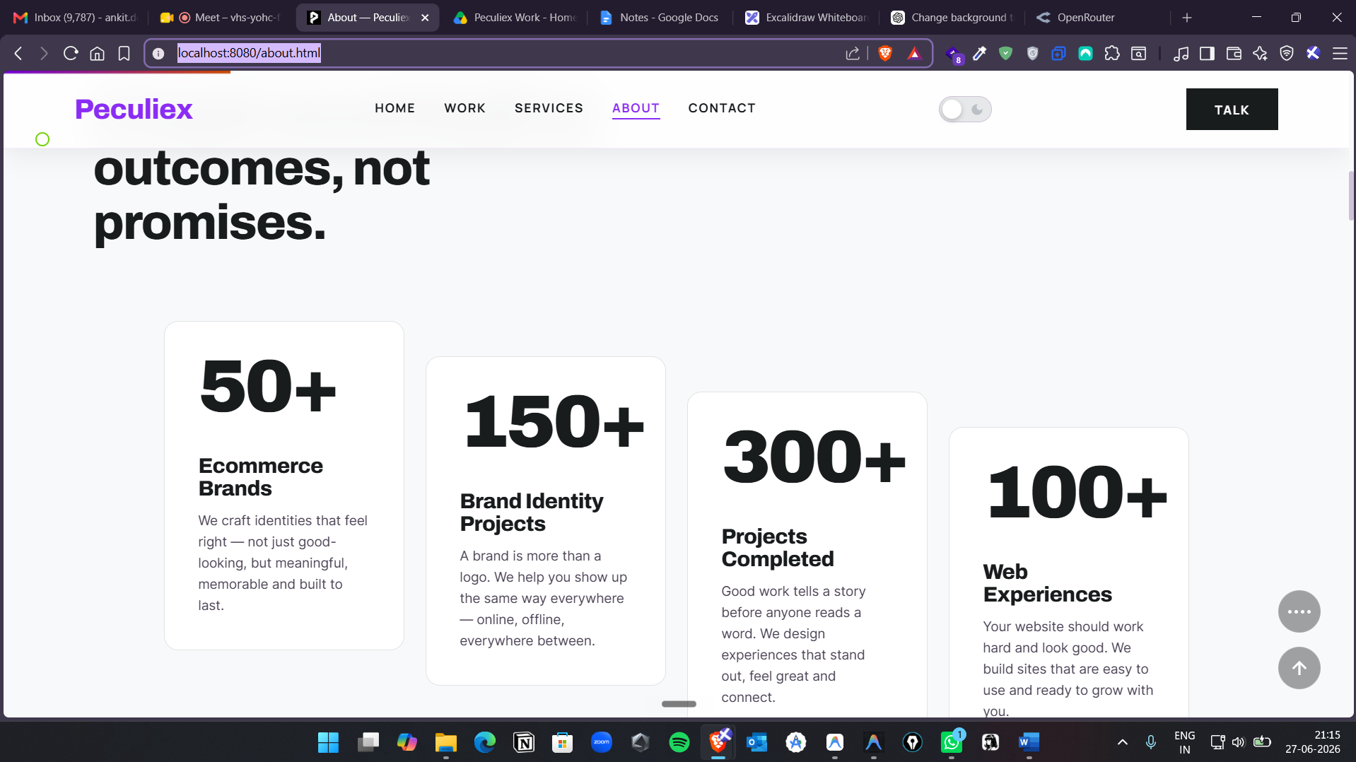

Add animation in the cards. Down animation in the card and one by one

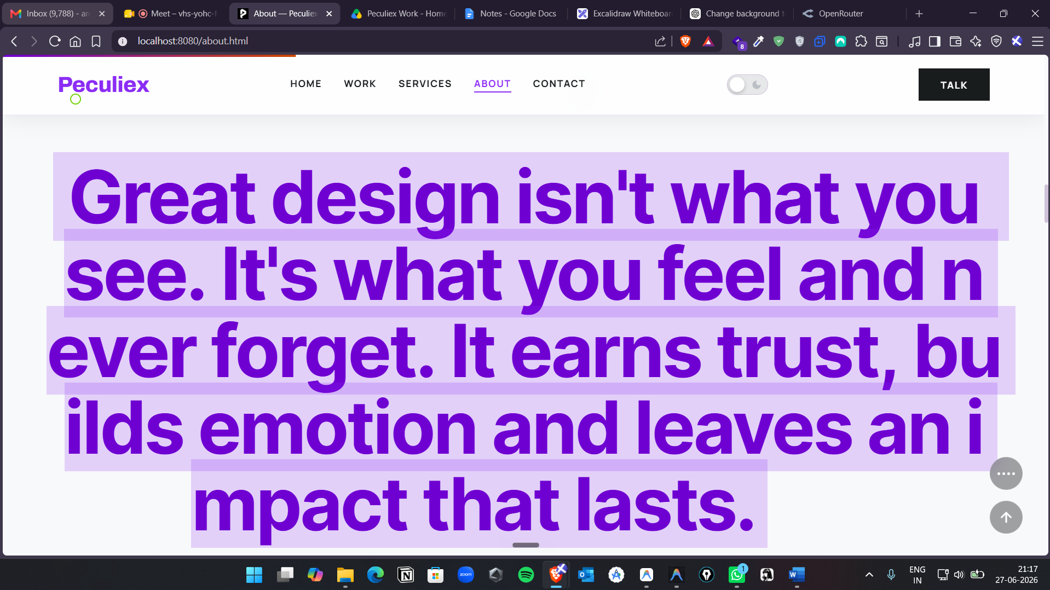

Change this whole paragraph text and make sure the text should be properly aligned.

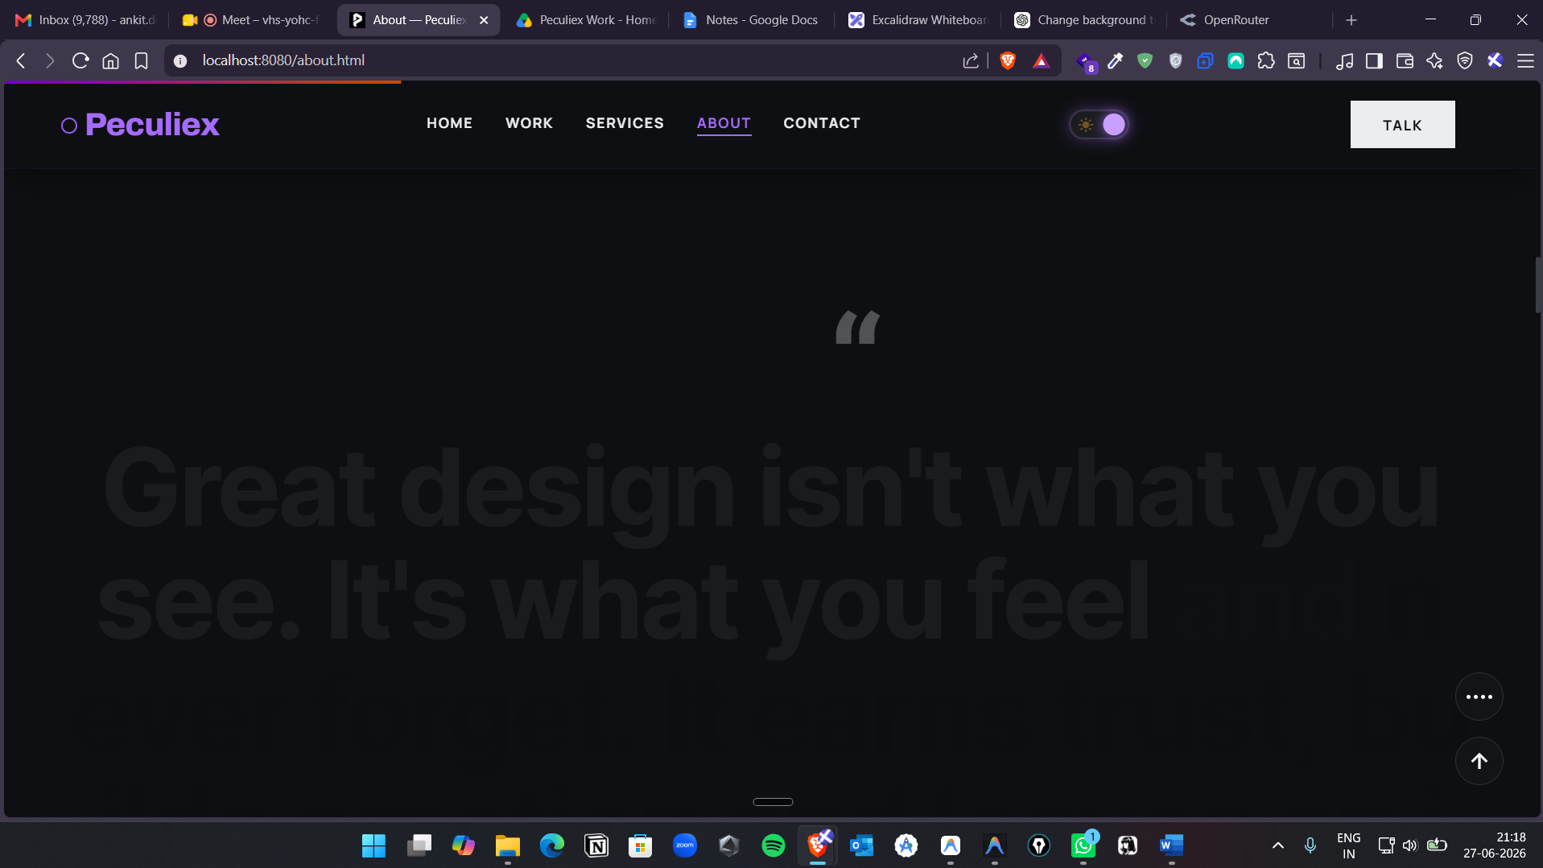
Not visible in the dark mode? Change the text color to white.
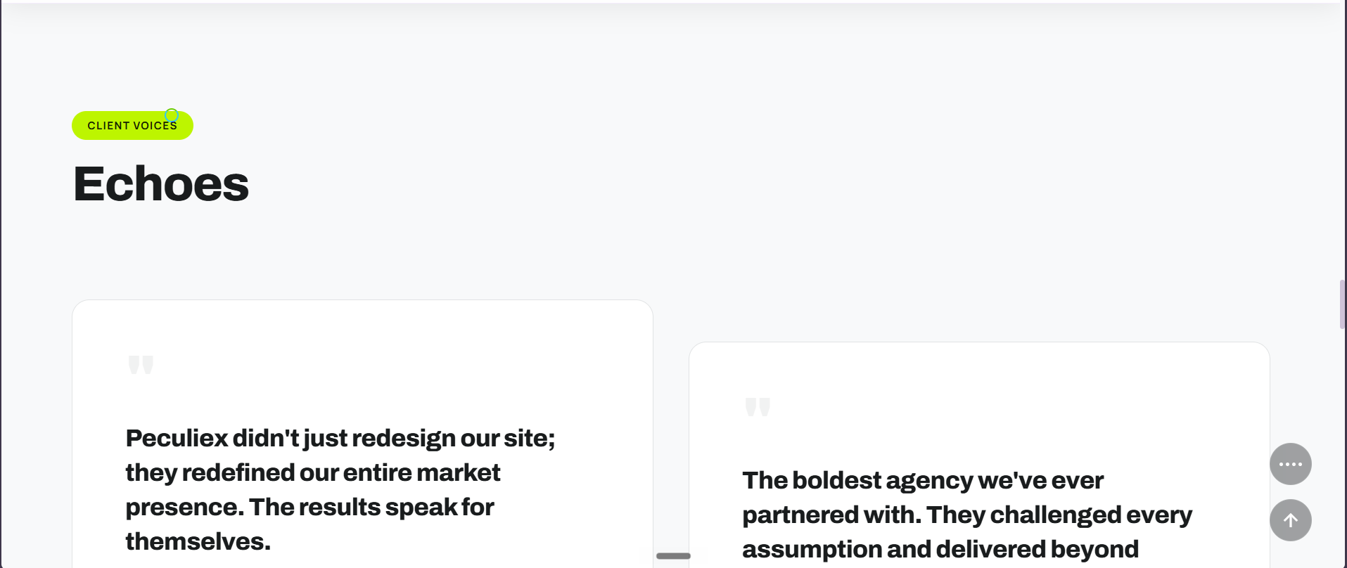

Change this section in the About page with this.
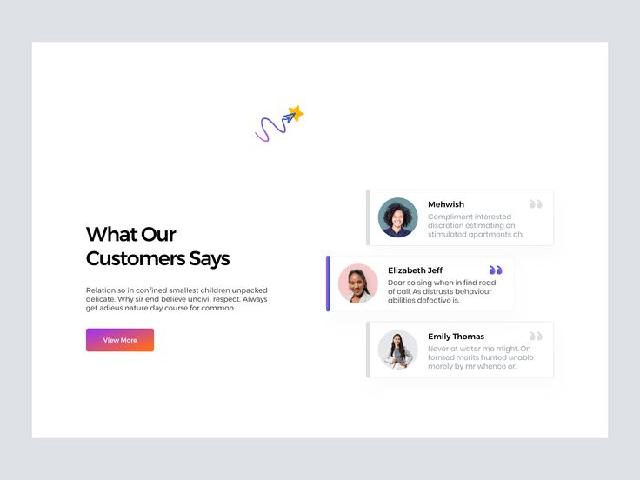
Client testimonial: the background should be glowing with different colors, white, your red, green, and blue, and also they are floating animation.

